STEGO Elektrotechnik GmbH, Schwäbisch Hall, 25/11/2021
Press release
Exciting tech careers

Aalen University Makeathon – support from STEGO for the use of digital tools in education

STEGO Elektrotechnik GmbH is providing support to universities in the context of the VDMA initiative entitled “Maschinenhaus – platform for innovative teaching”. First up was Aalen University with its Makeathon on the topic of ecological smart homes held from 2 to 5 November. Students developed interdisciplinary climate, resource and digitalisation solutions. Sixty first-year students on mechatronics, technical content creation, user experience and engineering pedagogy courses created hardware and software solutions with the aid of the STEGO CONNECT Industry 4.0 IIoT platform.

Maschinenhaus strengthens STEM subjects
Shortages of skilled workers, demographic change, unpopular STEM subjects (science, technology, engineering and mathematics) – these are just a few of the issues casting a shadow over the critical state of science and technical training in Germany. These phenomena are not new; indeed, the German Mechanical Engineering Industry Association (VDMA) has been actively tackling them since 2013 with its “Maschinenhaus – platform for innovative teaching” initiative.

The goal of the Maschinenhaus transfer projects is to encourage the integration of actual business and market needs into university teaching and help to ensure that educational content is suitably focused on these. Too many students are still dropping out of technical courses. This is very concerning for the German economy, for which these new talent represent a “traditional backbone” for innovative and complex products and services with Made in Germany quality.

Therefore, STEGO Managing Director Elmar Mangold quickly recognised the importance of taking part in the VDMA transfer project: “I am personally committed to getting young people excited about careers in engineering. Our active association work promoting the use of digital tools in education helps to link the spheres of educational institutions and businesses. We want to do our bit to solidify the appeal of tech careers. Aalen University is now making a start. As we go forward, we want to actively help other universities to gain practical access to Industry 4.0 applications.”

STEGO CONNECT IIoT platform
The concept for the concluding workshop on ecological smart homes was developed in cooperation with Mechatronics Professor Peter Eichinger. STEGO supported each of the six ten-student project teams by giving them cloud-based access to its internally developed STEGO CONNECT IIoT platform and providing demonstration cases with industrial hardware for automation solutions. Based on the Plug & Connect approach, the students were able to use these to bring their ideas and solutions to life.

Environmentally friendly, sustainable living in our homes formed the creative field of action for linking operational technology (OT) and information technology (IT) in the Makeathon. The students used the Industrial Internet of Things (IIoT) to bring the operational technology in the form of sensors and actuators up to a state-of-the-art level. The STEGO CONNECT IIoT platform functioned here as an information technology component, allowing the students to implement complicated, event-based interactions of building automation components in the process system in an intuitive, simple, clear and easily parameterisable way. The project teams came up with exciting solutions in areas such as building access control, air-conditioning and safety technology, to name just a few.

Mechatronics Professor Ulrich Schmitt, who drove the preparation, implementation and evaluation of the Maschinenhaus project, confirmed the event’s effectiveness. “In the Maschinenhaus transfer project, students can literally get to grips with their studies. They deal with a specific issue, translate that into a task, work on the project in an interdisciplinary manner within a team and bring their individual solution to life, which they then present to the auditorium at the end.”

The Makeathon’s successful conclusion was marked by the presentation of the Maschinenhaus certificate by VDMA educational expert Michael Patrick Zeiner. The Faculty of Optics & Mechatronics at Aalen University is thus the 59th faculty in Germany to be recognised for successfully completing the transfer project.

STEGO – perfect thermal management

Since being founded in 1980, STEGO Elektrotechnik GmbH in Schwäbisch Hall has been developing, producing and distributing a constantly growing product range for protecting electrical and electronic components. Enclosure heaters, filter fans, LED lights, thermostats, hygrostats and enclosure accessories ensure optimised climate conditions in all kinds of environments and guarantee permanently reliable operation of sensitive components.

www.stego.de

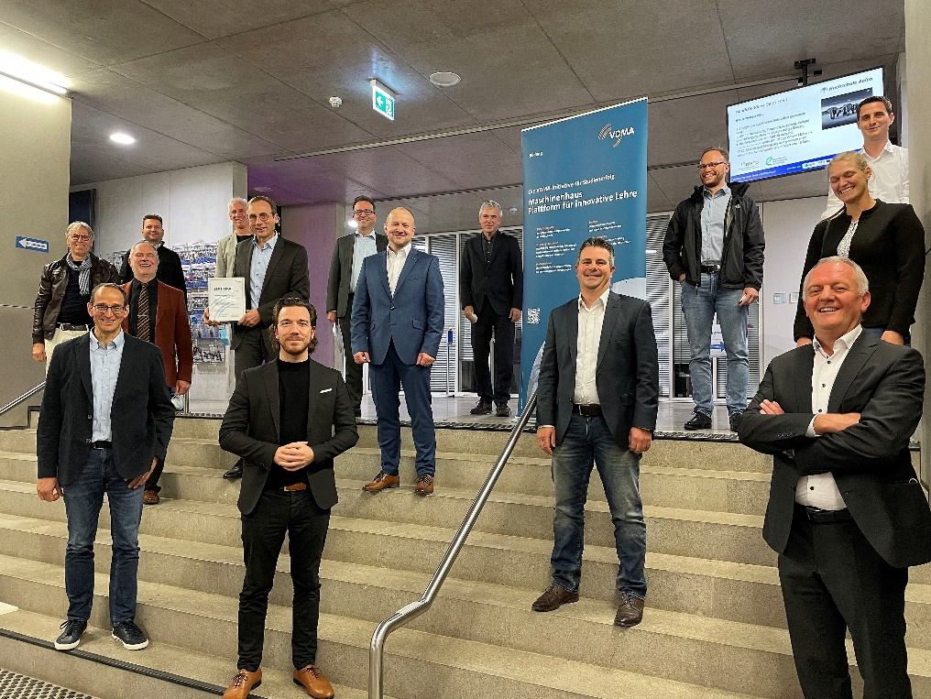

Caption.
Participants in the VDMA Maschinenhaus concluding event at Aalen University

Contact:
Siegfried Oerthel | soerthel@stego.de | Tel. +49 791 95058-181

STEGO Elektrotechnik GmbH
Kolpingstraße 21
D-74523 Schwäbisch Hall
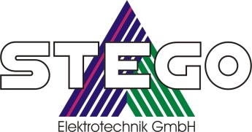
Germany
Scan me for
STEGO NEWSROOM

